NAME: VIJAYALAKSHMI S
REG NO: 192472326
COURSE CODE: CSA1216
COURSE NAME: COMPUTER ARCHITECTURE
ASSESSMENT TOOL : CO2 AT2

Q1. Signed Integer Addition Using 2's Complement
1. Identification of Errors / Bugs – 20%
For an 8-bit signed integer, the valid range is:
-128 to +127
Example:
120 + 50 = 170
But 170 cannot be represented using an 8-bit signed integer. If it is stored directly, the binary result wraps around and gives an incorrect negative value.
Bug: Overflow is not detected.

2. Debugging Approach & Analysis – 20%
For signed addition, overflow occurs when:
- Two positive numbers produce a negative result.
- Two negative numbers produce a positive result.
Another safe approach is to perform the calculation using a larger integer and check whether the result is within the 8-bit range.
3. Correctness of Debugged Solution – 25%
Python Code
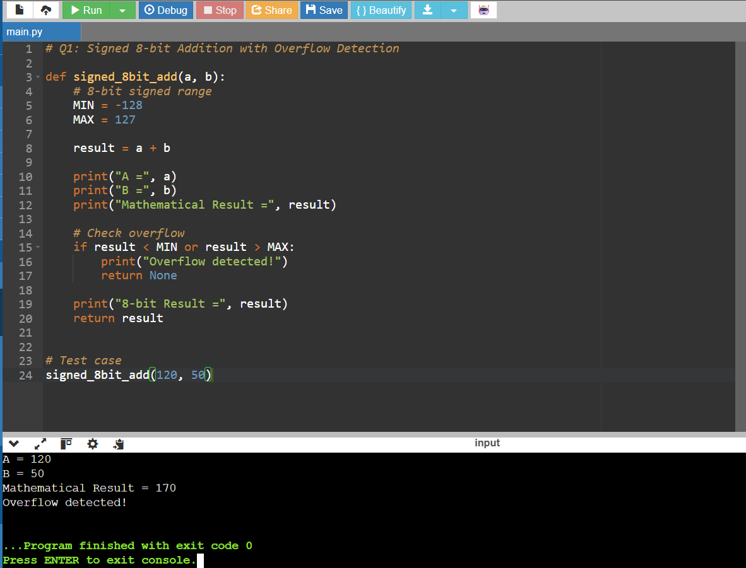
4. Optimization Techniques Applied – 20%
- Use a larger integer temporarily.
- Check the range before storing the result.
- Avoid unnecessary binary conversions.
- Overflow detection is performed in constant time: O(1)
4) Testing and Documentation
A | B | Expected
50 | 30 | 80
120 | 50 | Overflow
-100 | -40 | Overflow
-50 | 20 | -30
127 | 1 | Overflow

Conclusion
The program correctly identifies when the result exceeds the 8-bit signed range and prevents an incorrect result.

Q2. Ripple Carry Adder → Carry Look-Ahead Adder
1. Identification of Errors / Bugs – 20%
In a Ripple Carry Adder, every bit must wait for the carry from the previous bit.
For example:
Bit 0 → Bit 1 → Bit 2 → Bit 3
This creates propagation delay.
Problem: Slow carry propagation.

2. Debugging Approach & Analysis – 20%
For each bit, calculate:
Pi = Ai XOR Bi
Gi = Ai AND Bi
where:
- Pi = Propagate
- Gi = Generate
The carry can then be calculated directly instead of waiting for the previous bit.
3. Correctness of Debugged Solution – 25%
Python Code and output
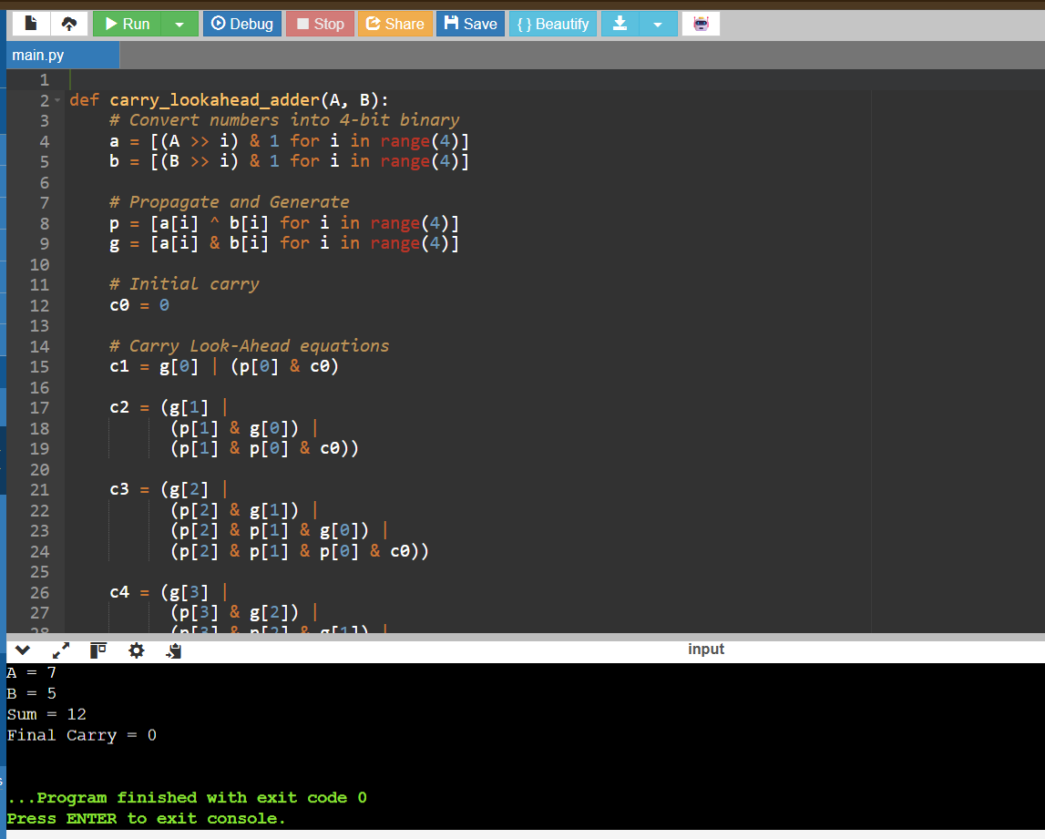

4. Optimization Techniques Applied – 20%
Ripple Carry:
Carry → Carry → Carry → Carry
CLA:
Carries calculated directly
Therefore, CLA reduces carry propagation delay and is faster for high-speed processors.
5. Testing and Documentation – 15%
A | B | Expected Sum
3 | 2 | 5
7 | 5 | 12
8 | 7 | 15
15 | 1 | 16

Conclusion
Carry Look-Ahead Addition improves arithmetic performance by calculating carries in advance rather than allowing them to ripple through every bit.

Q3. Booth's Signed Multiplication
1. Identification of Errors / Bugs – 20%
Incorrect Booth multiplication generally occurs because of:
- Incorrect Q0 and Q-1 checking.
- Wrong arithmetic shift.
- Loss of sign bit.
- Incorrect subtraction for negative operands.
- Incorrect register width.
The Booth rules are:
Q0 | Q-1 | Operation
0 | 0 | No operation
0 | 1 | A = A + M
1 | 0 | A = A - M
1 | 1 | No operation

2. Debugging Approach & Analysis – 20%
The algorithm maintains:
A = Accumulator
M = Multiplicand
Q = Multiplier
Q-1 = Previous Q bit
After every operation, perform an arithmetic right shift so that the sign bit is preserved.
3. Correctness of Debugged Solution – 25%
Python Code and output
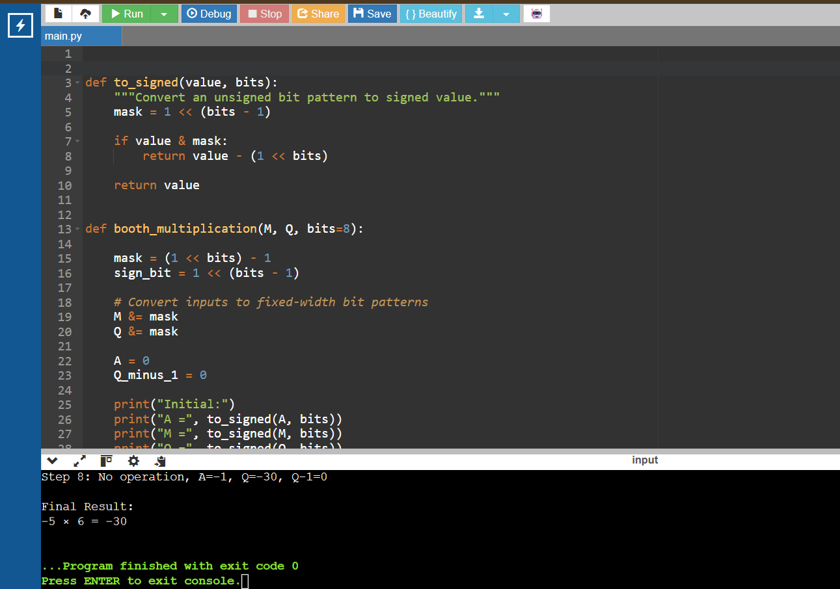

4. Optimization Techniques Applied – 20%
Booth's algorithm reduces unnecessary additions/subtractions when consecutive multiplier bits are the same.
Instead of performing multiplication using repeated addition, it uses:
- Bit-pair encoding.
- Addition/subtraction.
- Arithmetic shifting.
This improves signed multiplication efficiency.
5. Testing and Documentation – 15%
Test:
5 × 6 = 30
-5 × 6 = -30
5 × -6 = -30
-5 × -6 = 30
0 × 10 = 0
Conclusion
The corrected Booth algorithm handles both positive and negative operands correctly by maintaining proper Q0, Q-1, and sign extension during arithmetic shifting.

Q4. Non-Restoring Division
1. Identification of Errors / Bugs – 20%
In restoring division, whenever the partial remainder becomes negative, it is restored by adding the divisor again.
This causes:
Subtract → Negative → Restore
Repeated restoration creates unnecessary operations.
2. Debugging Approach & Analysis – 20%
Non-restoring division avoids immediate restoration.
The rule is:
If previous A ≥ 0:
A = A - M

If previous A < 0:
A = A + M
Then the quotient bit is determined based on the sign of the new remainder.
3. Correctness of Debugged Solution – 25%
Python Code
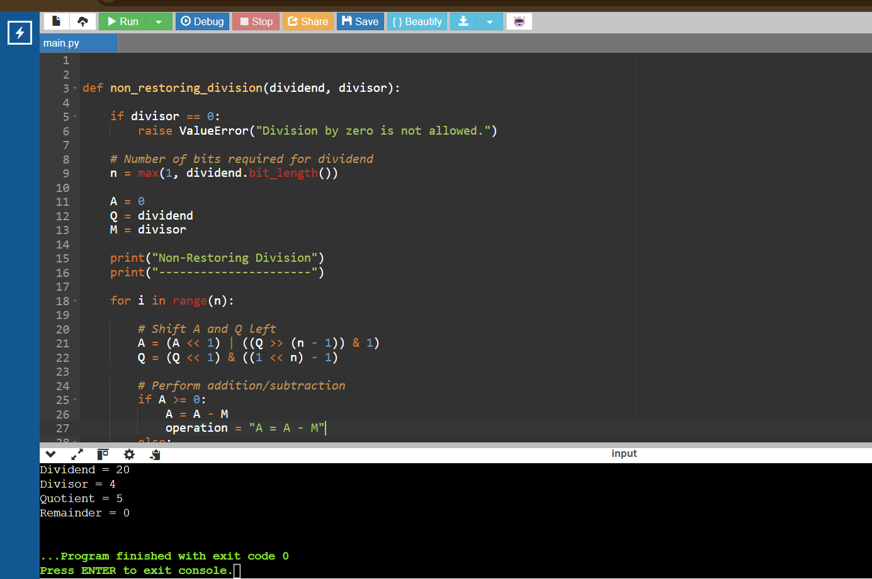

4. Optimization Techniques Applied – 20%
The optimized method is:
Restoring Division
Subtract
↓
If negative
↓
Restore
Non-Restoring Division
Subtract/Add
↓
Continue
↓
Correct only when required
Thus, unnecessary restoration operations are reduced.
5. Testing and Documentation – 15%

Dividend | Divisor | Quotient | Remainder
20 | 4 | 5 | 0
25 | 5 | 5 | 0
17 | 4 | 4 | 1
10 | 3 | 3 | 1

Conclusion
Non-restoring division improves performance by avoiding repeated restoration of the partial remainder.

Q5. IEEE 754 Single Precision Floating Point
1. Identification of Errors / Bugs – 20%
IEEE 754 single precision contains:
Sign = 1 bit
Exponent = 8 bits
Fraction = 23 bits
Total = 32 bits
A float has limited precision. When adding a very large and very small number, the smaller number may have little or no effect because of exponent alignment and rounding.
Example:
100000000 + 0.00000001
The small value can be lost in single precision.

2. Debugging Approach & Analysis – 20%
The main causes are:
- Exponent alignment.
- Limited 23-bit fraction.
- Rounding.
- Loss of significant digits.
To improve accuracy, use double precision, which provides a larger significand.

3. Correctness of Debugged Solution – 25%
Python Code and output
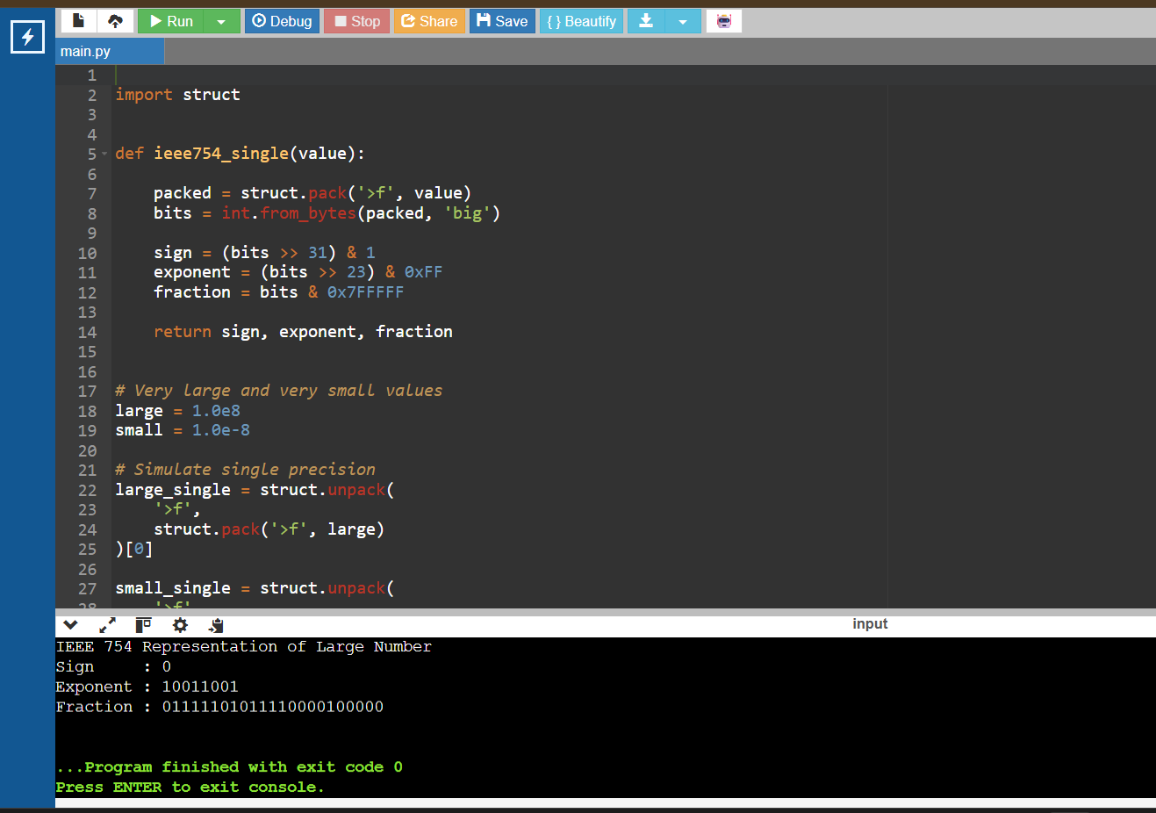
4. Optimization Techniques Applied – 20%
Original
Python
Run
float
Optimized
Python
Run
double precision
Other techniques include:
- Avoiding unnecessary conversions.
- Using numerically stable algorithms.
- Using higher precision when required.
- Applying suitable rounding methods.

5. Testing and Documentation – 15%
Large Value | Small Value | Purpose
1e8 | 1e-8 | Precision loss
1e5 | 1e-5 | Exponent difference
1.0 | 1e-8 | Small-value addition
1e10 | 1e-10 | Large exponent difference

Conclusion
Single precision has limited accuracy because of its 23-bit fraction. Double precision provides greater precision and is therefore preferred when scientific calculations require accurate results.

